EXPERIMENT-2
- Perform basic Image Handling and processing operations on the image is to read an image in python and Convert an Image to Blur using Gaussian Blur.

- CODE
- from PIL import Image, ImageFilter

- img = Image.open("photo.jpg")

- blurred = img.filter(ImageFilter.GaussianBlur(radius=5))

- blurred.save("blurred_photo.jpg")

- print("Image converted to Gaussian blur successfully")

b) INPUT
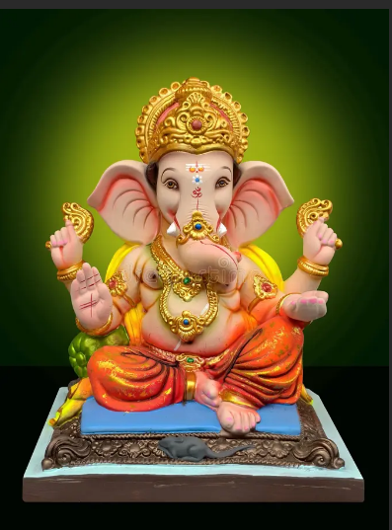
c) OUTPUT
